# A

PROJECT REPORT ON

**LPG Cylinders Distributor Software**

By

Devendrakumar Raiyani (CE-107) (17CEUOG022)

&

Smit Patel (CE-092)

(17CEUOS110)

B.Tech CE Semester-VI

Subject: OOSE

**Guided by:**

Prof. P.M.Jadav

Associated Professor Dept. of Comp. Engg.



Faculty of Technology Department of Computer Engineering

Dharmsinh Desai University



Faculty of Technology

Department of Computer Engineering

Dharmsinh Desai University

**CERTIFICATE**

This is to certify that the practical / term work carried out in the subject of

**OOSE** and recorded in. This journal is the bonafide work of

Devendrakumar Raiyani (CE-107) (17CEUOG022)

&

Smit Patel (CE-092) ()

of B.Tech semester **VI** in the branch of **Computer Engineering**

during the academic year **2019-2020**.

Prof. Pandav K. Patel Dr. C. K. Bhensdadia,

Assistant Professor, Head,

Dept. of Computer Engg., Dept. of Computer Engg.,

Faculty of Technology Faculty of Technology

Dharmsinh Desai University, Nadiad Dharmsinh Desai University,Nadiad

**CONTENTS**

1. Abstract……………………………………………….4

2. Introduction.…………………………………………..5

2.1 Brief Introduction ………………………..5

2.2 Technology/Platform/Tools Used …………5

3. Software Requirement Specifications……….……...6-7

4. Design……………………………………...…………8

4.1 Use Case Diagrams……..……….………8-12

4.2 Class Diagrams..………………..………….13

4.3 Sequence Diagrams………………………..14

4.4 Activity Diagrams………………………....15

4.5 State Diagrams…………………………….16

4.6 E-R Diagram....…….…………...…………14

4.7 Data dictionary….……………………...15-16

5. Implementation Detail…………………….…………17

5.1 Modules …………………………………...17

5.2 Functional Prototypes ……………………..17

6. Testing…..…...……...……...……………….……18-20

7. Screen-shots….………………………………..….21-27

8. Conclusion...…………………………………….……28

9. Limitation and Future Extension…...……………...…28

10. Bibliography……………………………………...…..29

**ABSTRACT**

**INTODUCTION**

**SOFTWARE REQUIREMENT SPECIFICATION**

**for**

**LPG CYLINDERS DISTRIBUTOR SOFTWARE**

1. User Login:

*Description:* User Can Login into System using correct credentials

*Input:* Username and Password.

*Output:* Home window if Credentials is correct otherwise error message.

1. Customer Management:

*Description:* Using this Functionality distributor user can create new customer, remove customer, change customer details.

R2.1 Create Customer

*Input:* Customer Details like name, Aadhaar number, address, contact number, type of connection.

*Output:* Success Message “Customer created Successfully”.

R2.2 Change Customer Details

*Input:* Customer Details for change.

*Output:* Success Message “Customer details updated Successfully”.

R2.3 Remove Customer

*Input:* Customer ID or Name

*Output:* Success Message “Customer removed Successfully”.

R2.4 Customer Details

*Description:* Distributor user can search customer by connection type, date, village, and view customer details.

*Input:* Required data to search records.

*Output:* List of Customers as per Input.

R2.5 Transfer Customer

*Description:* Distributor user can transfer customers from his agency to another agency.

*Input:* Selection of records and destination agency name

*Output:* Success Message “Transfer of Customers is Successfully done”.

1. Stock Management:

*Description:* Distributor user can add, view stock and can set price for cylinders, stoves and regulators.

R3.1 Add Stock

R3.1.1 Add Cylinders

*Input:* Numbers of various types of cylinders

*Output:* Success message

R3.1.2 Add Stoves and Regulators

*Input:* Numbers of various types of stoves and regulators

*Output:* Success message

R3.2 View Stock

*Input:* User selection

*Output:* Stock details of cylinders, stoves and regulators.

R3.3 Set Price

*Description:* Distributor user can set prices of cylinders, stoves and regulators.

*Input:* Prices of cylinders, stoves and regulators.

*Output:* Successful message

1. Synchronization with Central Server:

*Description:* Distributor user can synchronize customer transactions, changes of customers’ details and stock data within given time period for a day.

*Input:* User selection

*Output:* Success message

*Process:* Transfer Local data like customer transactions, changes of customers’ details and stock data to central server.

1. Customer Transaction:

*Description:* Distributor user can book cylinders, print bill of cylinders, stoves and regulator.

R5.1 Book Cylinder

*Input:* User will search customer and select “Register Booking”.

*Output:* Successful message

*Process:* record of this transaction is saved in record with unique transaction number.

R5.2 Print Bill of Cylinder

*Input:* Single or multiple records of cylinder refilling.

*Output:* Bill will be printed for selected records.

R5.3 Print Bill for Stoves and Regulator

*Input:* Distributor user will enter details like customer name, stove and regulator quantity.

*Output:* Bill will be printed.

1. Accounting:

*Description:* Distributor user can get details of sold and purchased cylinders, stoves and regulators for period entered by user. User can also generate pdf of those details.

R6.1 Summary Report

*Input:* User Selection.

*Output:* Summarized Report.

R6.2 Cylinder Report

*Input:* User Selection.

*Output:* Report of Cylinders.

R6.3 Stove and Regulator Report

*Input:* User Selection.

*Output:* Report of Stoves and Regulator.

**DESIGN**

* 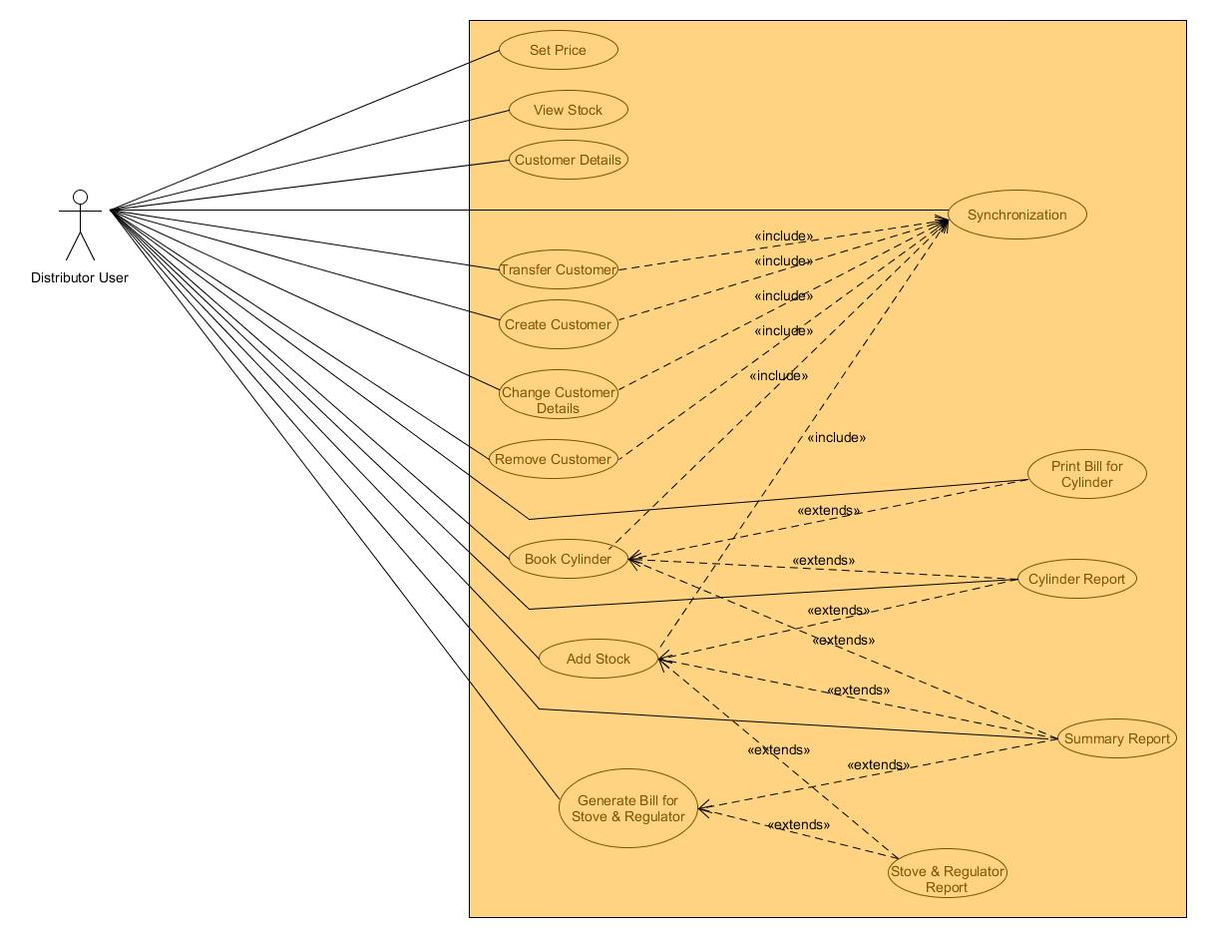**Use Case Diagrams:**
* 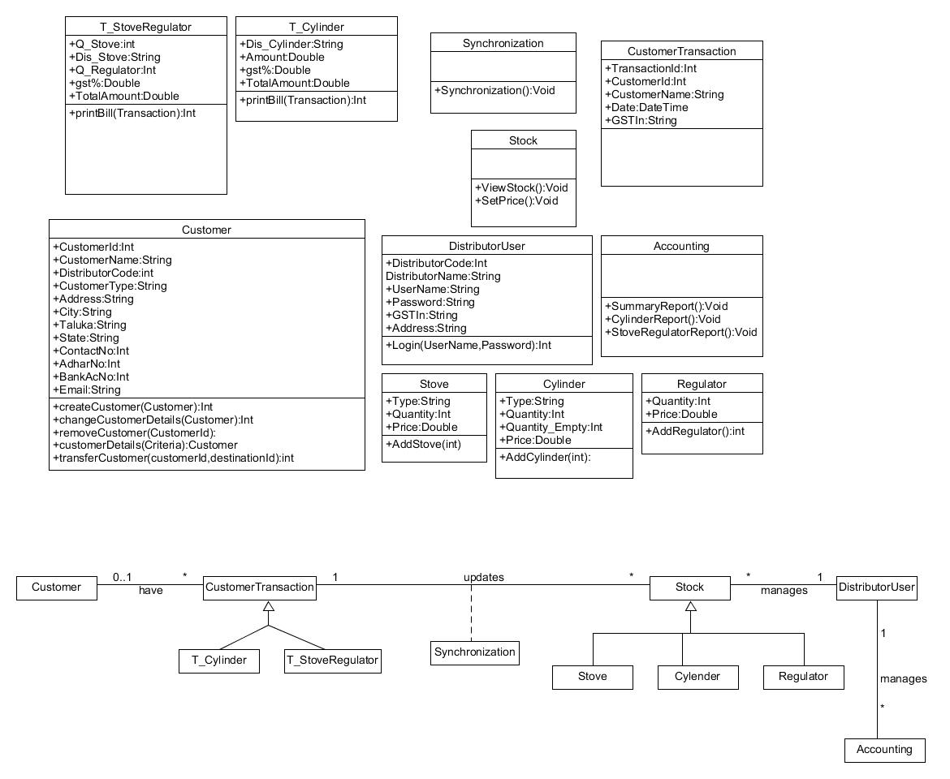**Class Diagrams:**
* 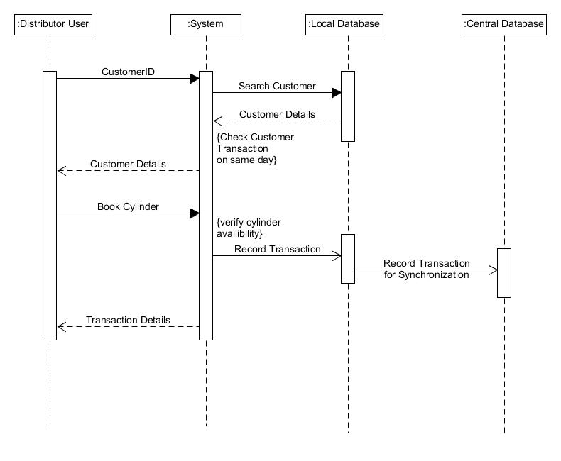**Sequence Diagrams:**
* **State Diagrams:**

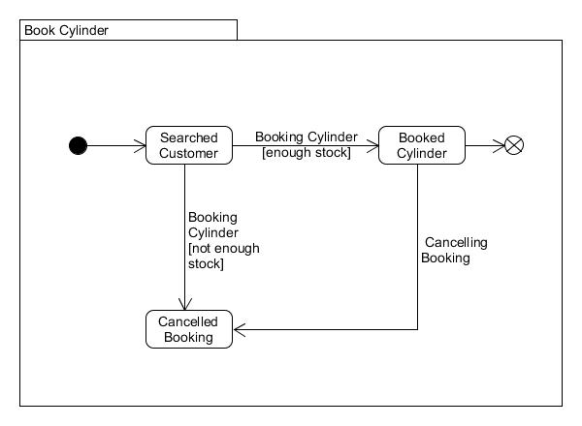

* 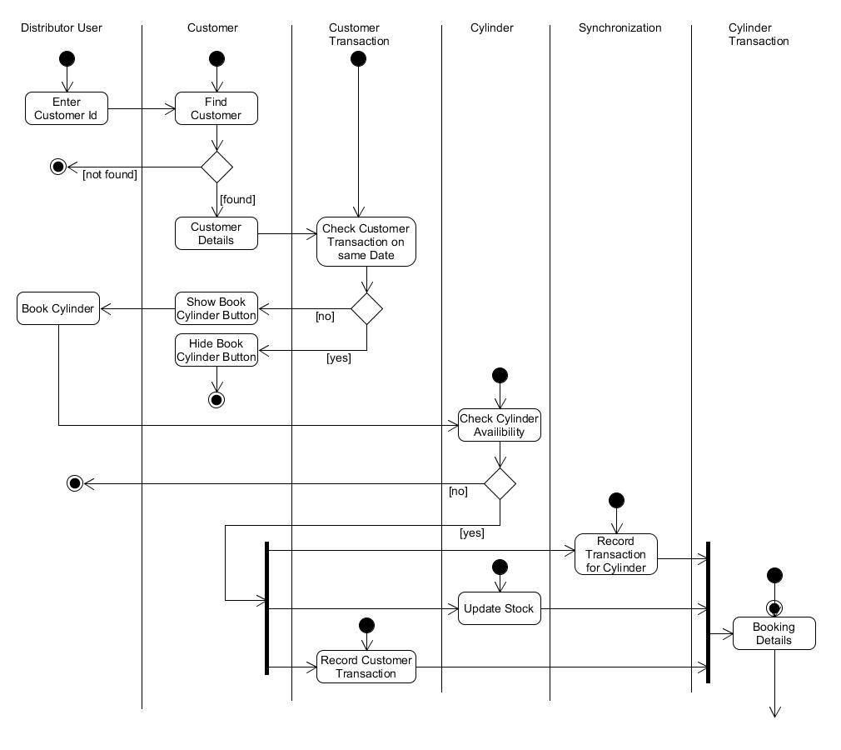**Activity Diagrams:**
* 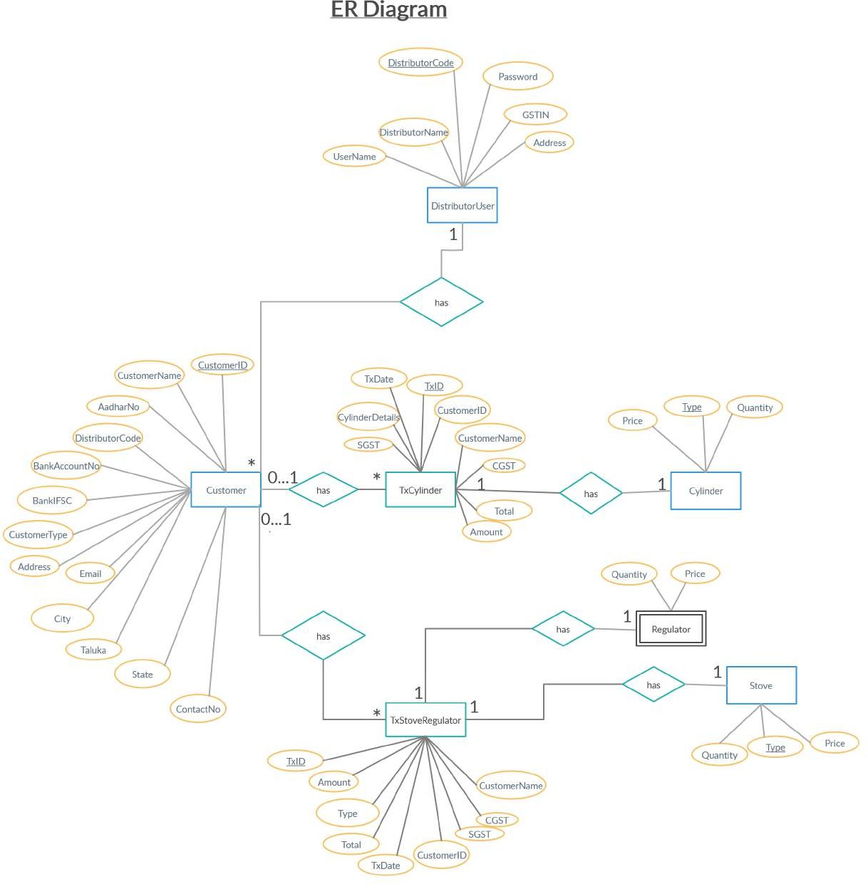**E-R Diagram:**
* **Data Dictionary:**

|  |  |  |  |  |  |  |  |
| --- | --- | --- | --- | --- | --- | --- | --- |
| **Customer** | | | | | | | |
| **Sr. No.** | **Field Name** | **Data Type** | **Width** | **Required** | **Unique** | **PK/FK** | **Referenced Table** |
| 1. | CustomerId | Int | 10 | Yes | Yes | PK |  |
| 2. | DistributorCode | Int | 6 | Yes |  | FK | DistributorUser |
| 3. | CustomerName | Varchar2 | 30 | Yes |  |  |  |
| 4. | CustomerType | Varchar2 | 10 | Yes |  |  |  |
| 5. | Address | Varchar2 | 100 | Yes |  |  |  |
| 6. | City | Varchar2 | 20 | Yes |  |  |  |
| 7. | Taluka | Varchar2 | 20 | Yes |  |  |  |
| 8. | State | Varchar2 | 20 | Yes |  |  |  |
| 9. | ContactNo | Int | 10 |  |  |  |  |
| 10. | Email | Varchar2 | 50 |  |  |  |  |
| 11. | AadharNo | Int | 12 | Yes | Yes |  |  |
| 12. | BankIFSC | Varchar2 | 15 |  |  |  |  |
| 13. | BankAccountNo | Int | 16 |  | Yes |  |  |

|  |  |  |  |  |  |  |  |
| --- | --- | --- | --- | --- | --- | --- | --- |
| **DistributorUser** | | | | | | | |
| **Sr.**  **No.** | **Field Name** | **Data Type** | **Width** | **Required** | **Unique** | **PK/FK** | **Referenced Table** |
| 1. | DistributorCode | Varchar2 | 6 | Yes | Yes | PK |  |
| 2. | DistributorName | varchar2 | 30 | Yes |  |  |  |
| 3. | Username | Varchar2 | 12 | Yes |  |  |  |
| 4. | Password | Varchar2 | 12 | Yes |  |  |  |
| 5. | GSTIN | Varchar2 |  | Yes | Yes |  |  |
| 6. | Address | Varchar2 | 100 | Yes |  |  |  |

|  |  |  |  |  |  |  |  |
| --- | --- | --- | --- | --- | --- | --- | --- |
| **Cylinder** | | | | | | | |
| **Sr. No.** | **Field Name** | **Data Type** | **Width** | **Required** | **Unique** | **PK/FK** | **Referenced Table** |
| 1. | Type | Varchar2 | 15 | Yes | Yes | PK |  |
| 2. | Quantity | Int | 5 | Yes |  |  |  |
| 3. | Price | Double |  | Yes |  |  |  |

|  |  |  |  |  |  |  |  |
| --- | --- | --- | --- | --- | --- | --- | --- |
| **Stove** | | | | | | | |
| **Sr. No.** | **Field Name** | **Data Type** | **Width** | **Required** | **Unique** | **PK/FK** | **Referenced Table** |
| 1. | Type | Varchar2 | 15 | Yes | Yes | PK |  |
| 2. | Quantity | Int | 5 | Yes |  |  |  |
| 3. | Price | Double |  | Yes |  |  |  |

|  |  |  |  |  |  |  |  |
| --- | --- | --- | --- | --- | --- | --- | --- |
| **TxCylinder** | | | | | | | |
| **Sr. No.** | **Field Name** | **Data Type** | **Width** | **Required** | **Unique** | **PK/FK** | **Referenced Table** |
| 1. | TxId | Int | 10 | Yes | Yes | PK |  |
| 2. | CustomerId | Int | 10 | Yes |  | FK | Customer |
| 3. | CustomerName | Varchar2 | 30 | Yes |  |  |  |
| 4. | TxDate | DateTime |  | Yes | Yes |  |  |
| 5. | CylinderDetails | Varchar2 | 50 | Yes |  | FK | Cylinder |
| 6. | Amount | Double |  | Yes |  |  |  |
| 7. | CGST | Double |  | Yes |  |  |  |
| 8. | SGST | Double |  | Yes |  |  |  |
| 9. | Total | Double |  | Yes |  |  |  |

|  |  |  |  |  |  |  |  |
| --- | --- | --- | --- | --- | --- | --- | --- |
| **TxStoveRegulator** | | | | | | | |
| **Sr. No.** | **Field Name** | **Data Type** | **Width** | **Required** | **Unique** | **PK/FK** | **Referenced Table** |
| 1. | TxId | Int | 10 | Yes | Yes | PK |  |
| 2. | CustomerId | Int | 10 |  |  | FK | Customer |
| 3. | CustomerName | Varchar2 | 30 |  |  |  |  |
| 4. | TxDate | DateTime |  |  | Yes |  |  |
| 5. | Details | Varchar2 | 50 | Yes |  | FK | Stove |
| 6. | Amount | Double |  | Yes |  |  |  |
| 7. | CGST | Double |  | Yes |  |  |  |
| 8. | SGST | Double |  | Yes |  |  |  |
| 9. | Total | Double |  | Yes |  |  |  |

**IMPLEMENTION DETAILS**

**TESTING**

**SCREEN-SHOTS**

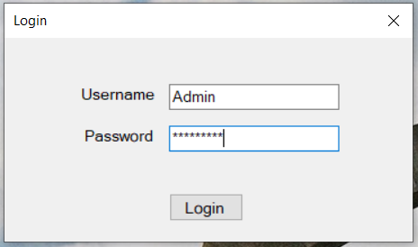

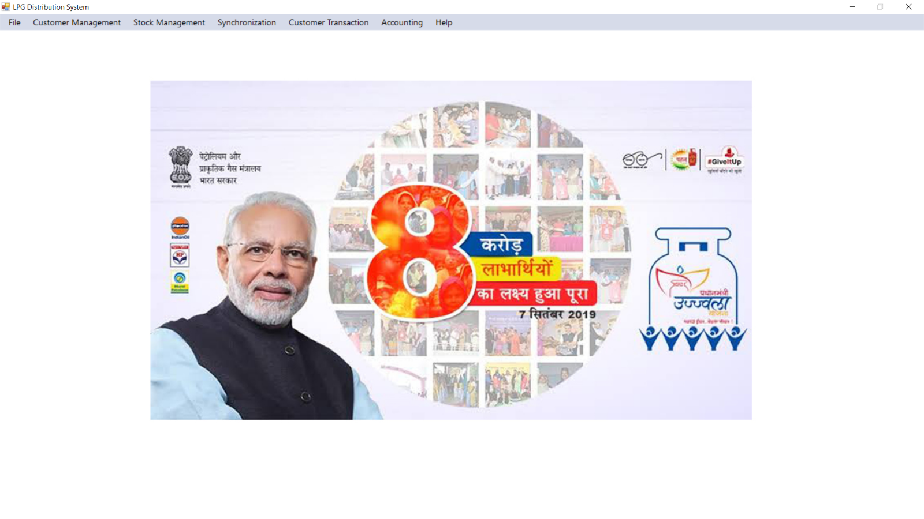

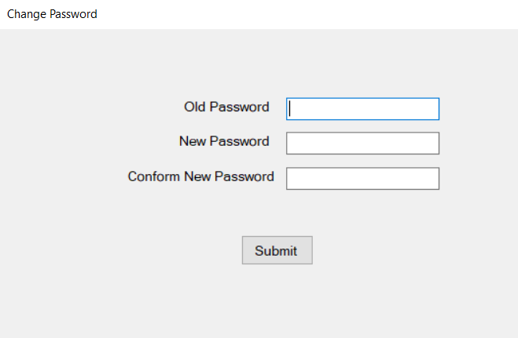

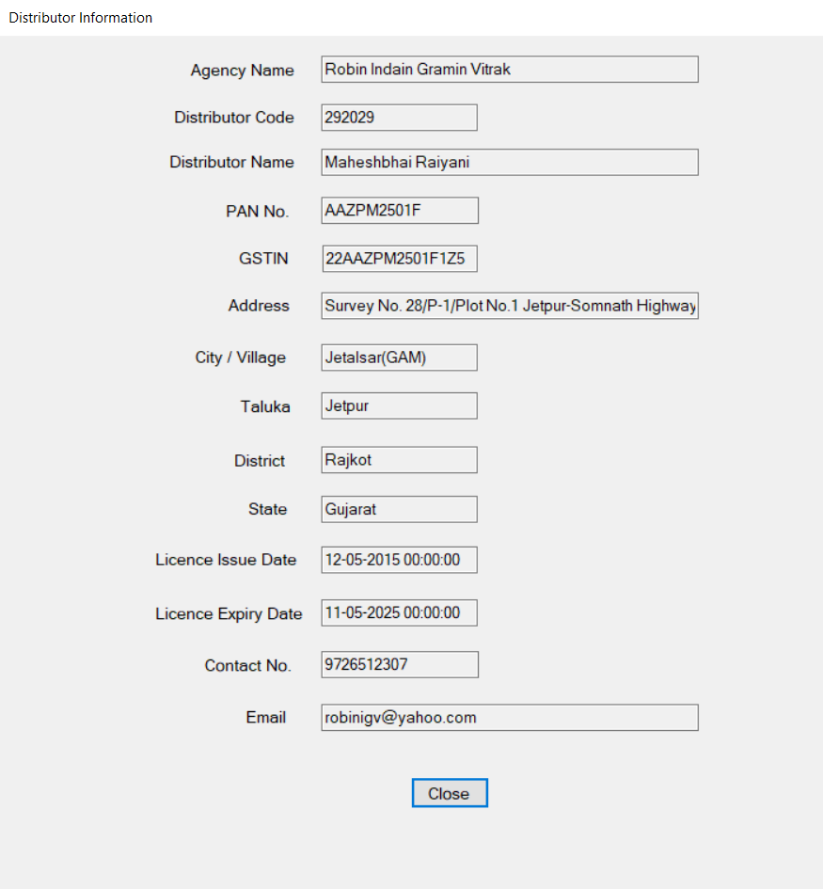

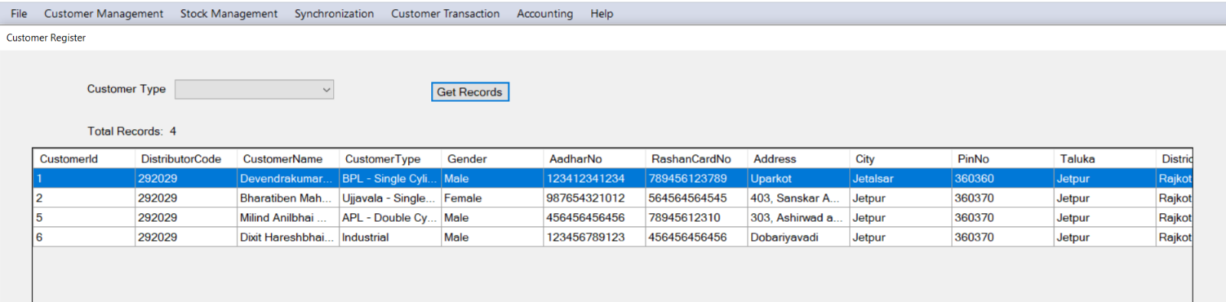

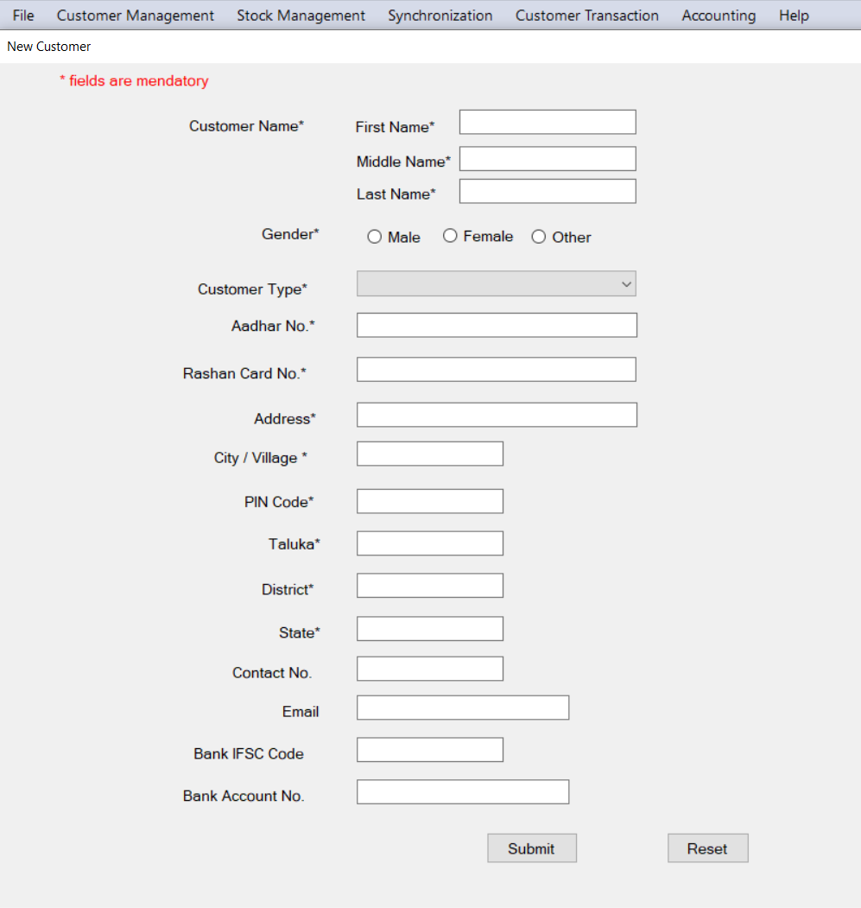

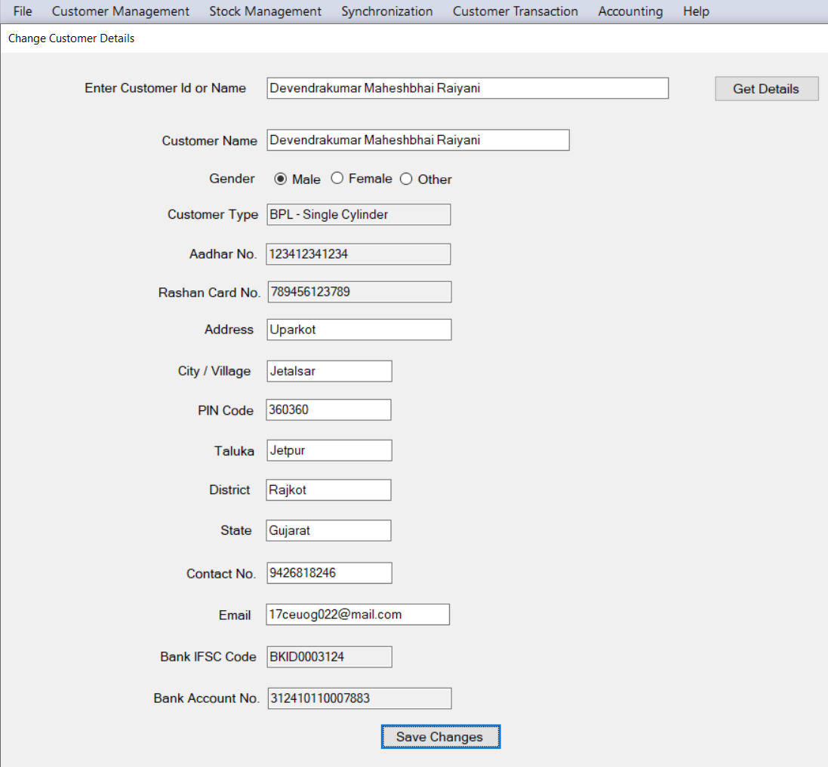

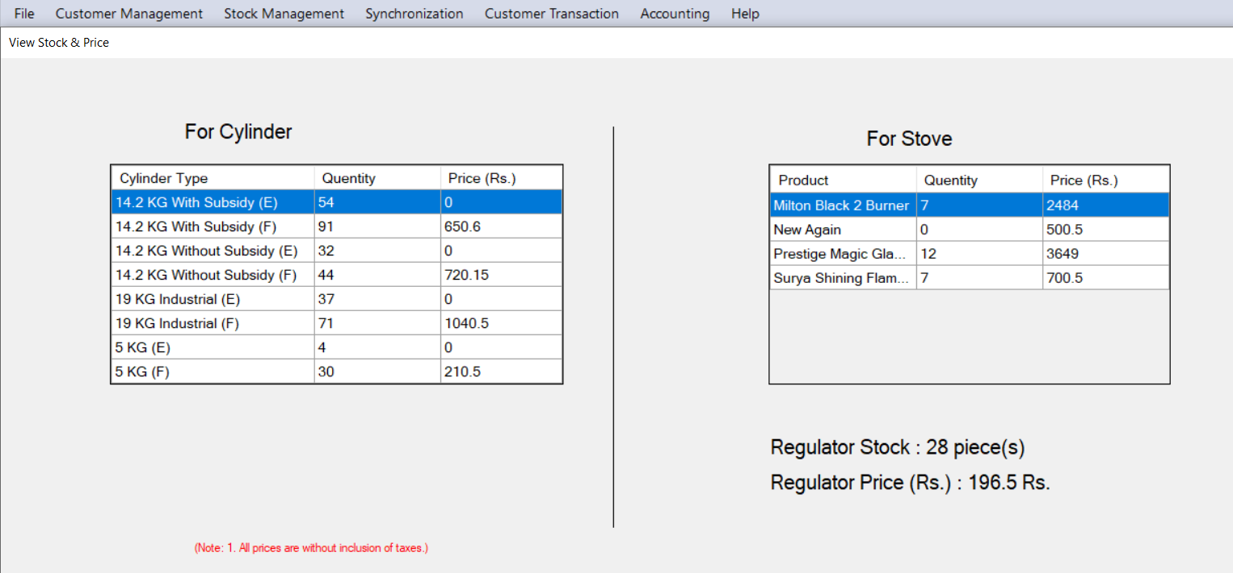

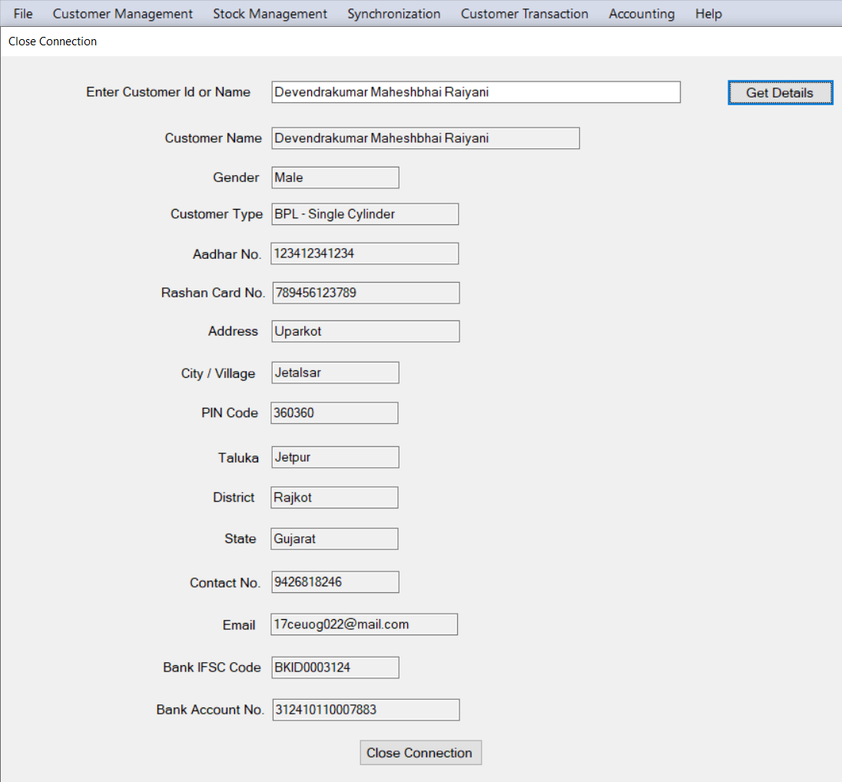

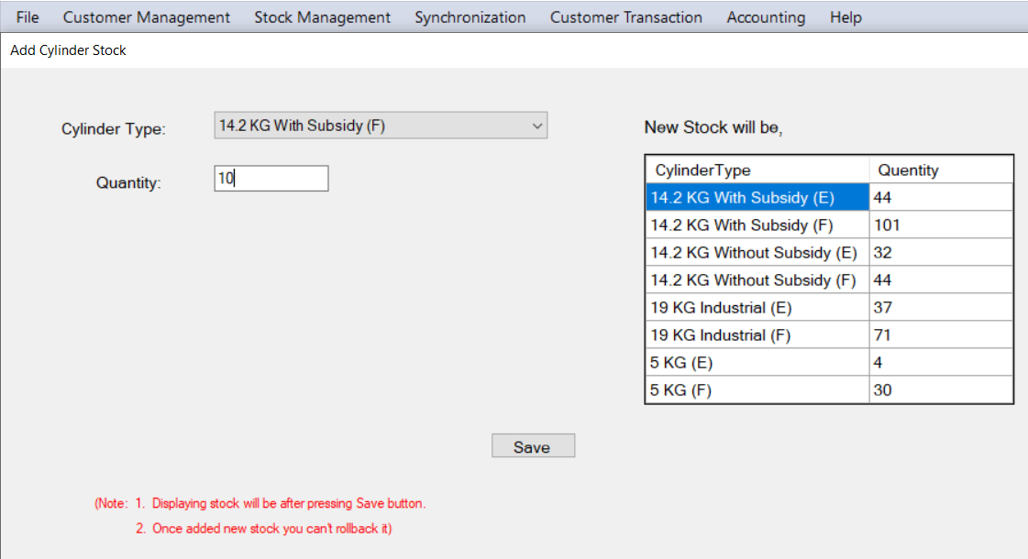

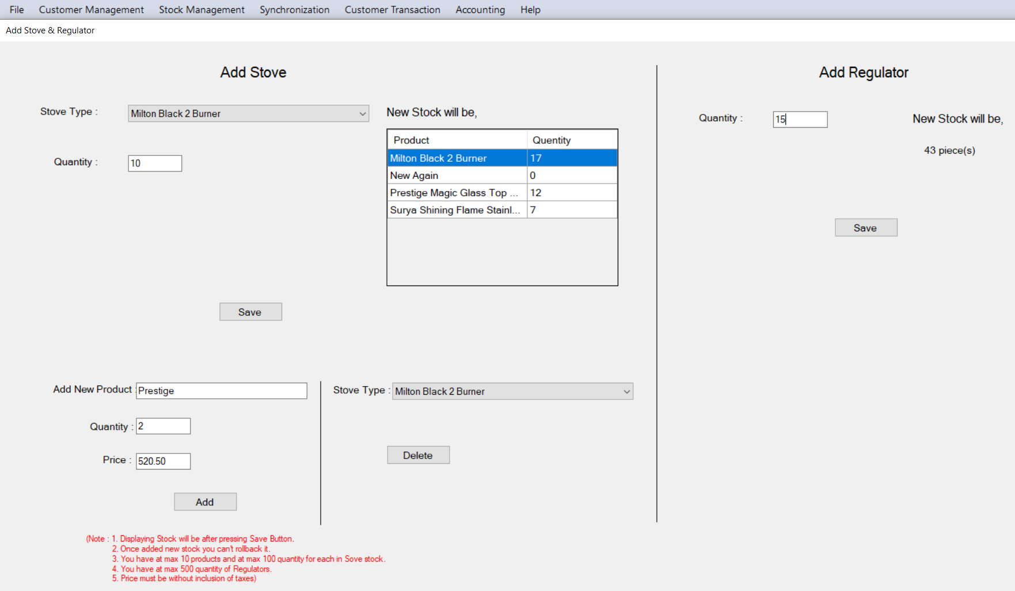

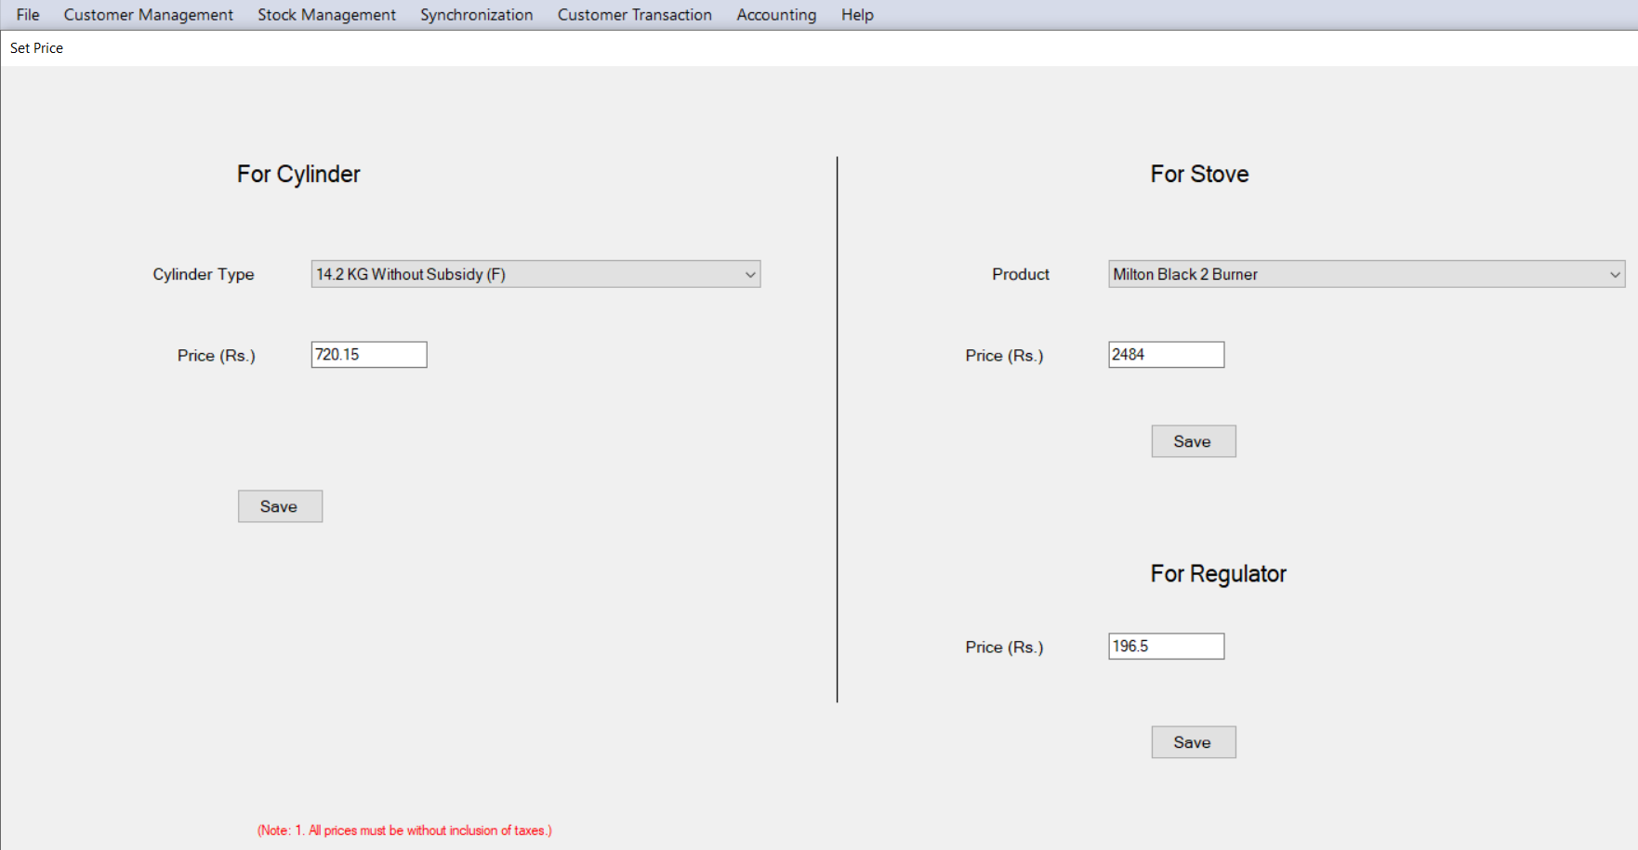

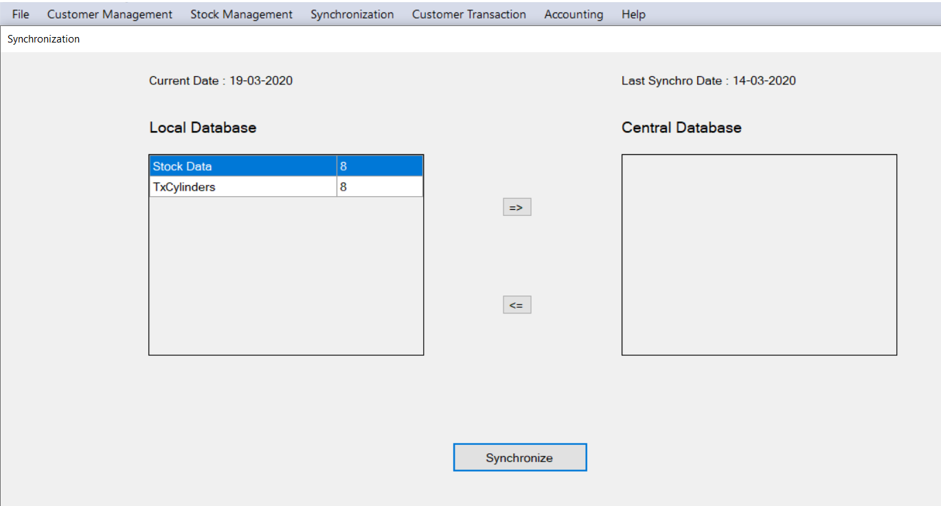

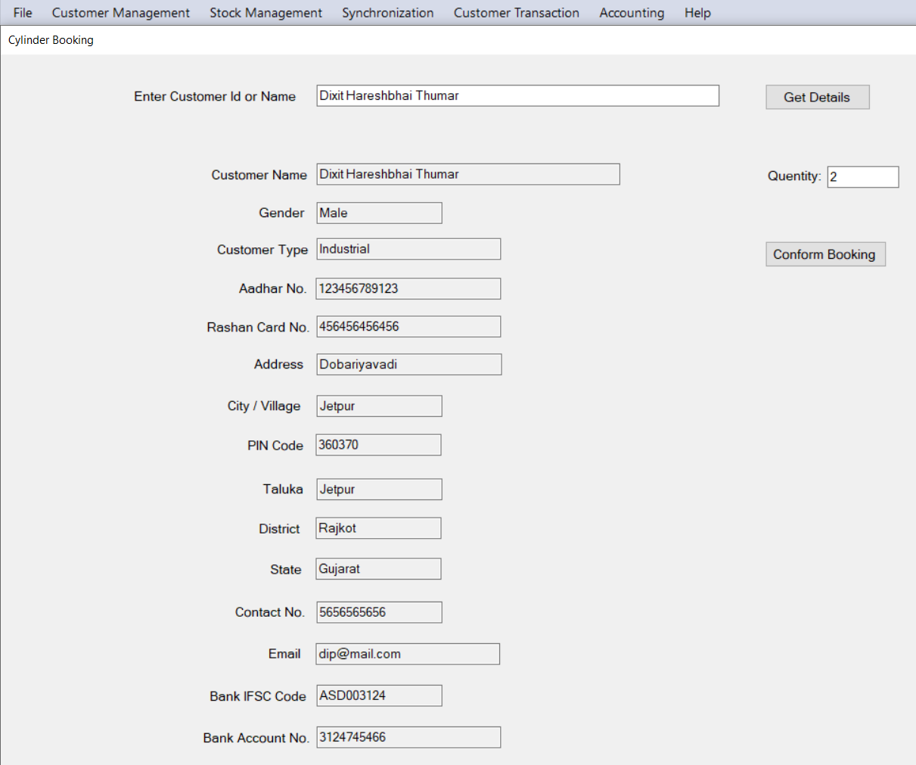

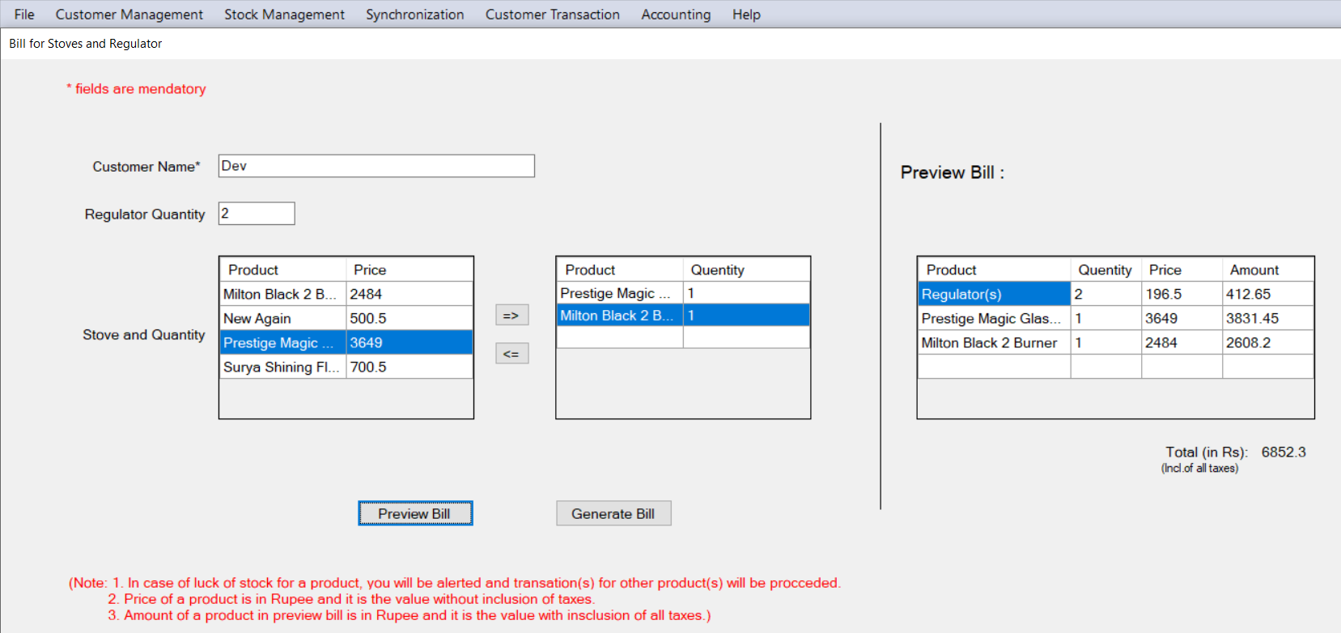

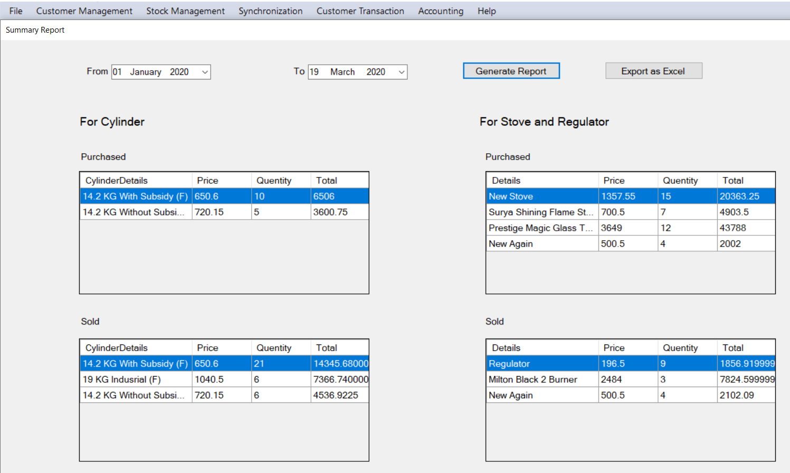

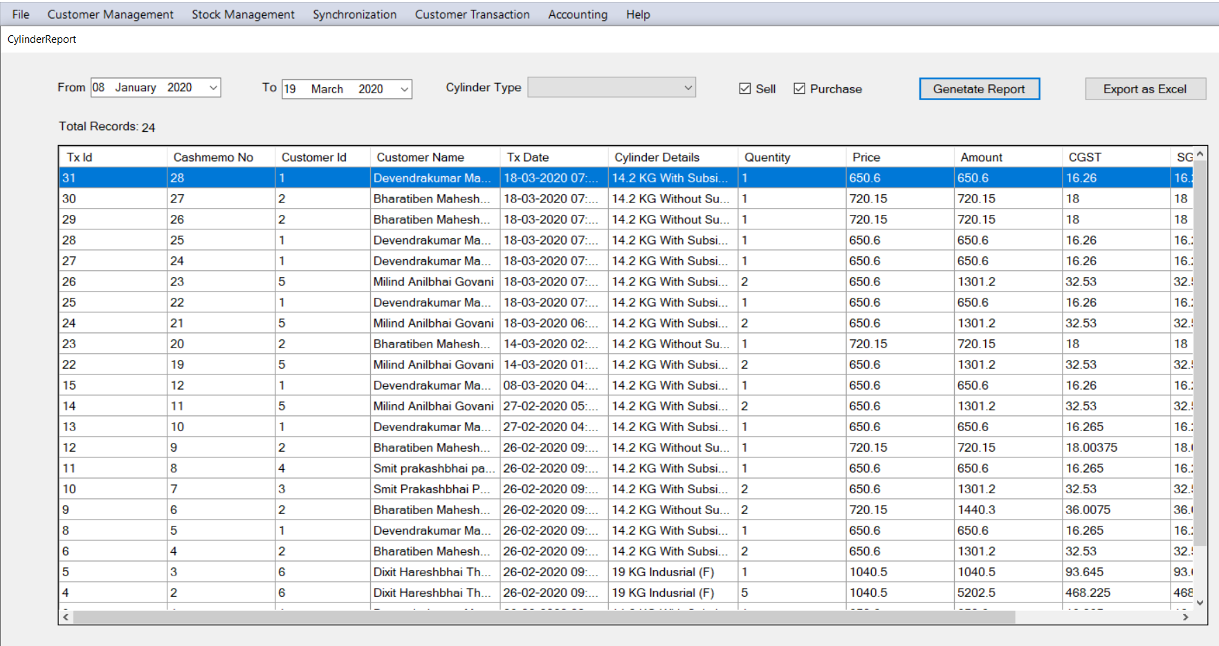

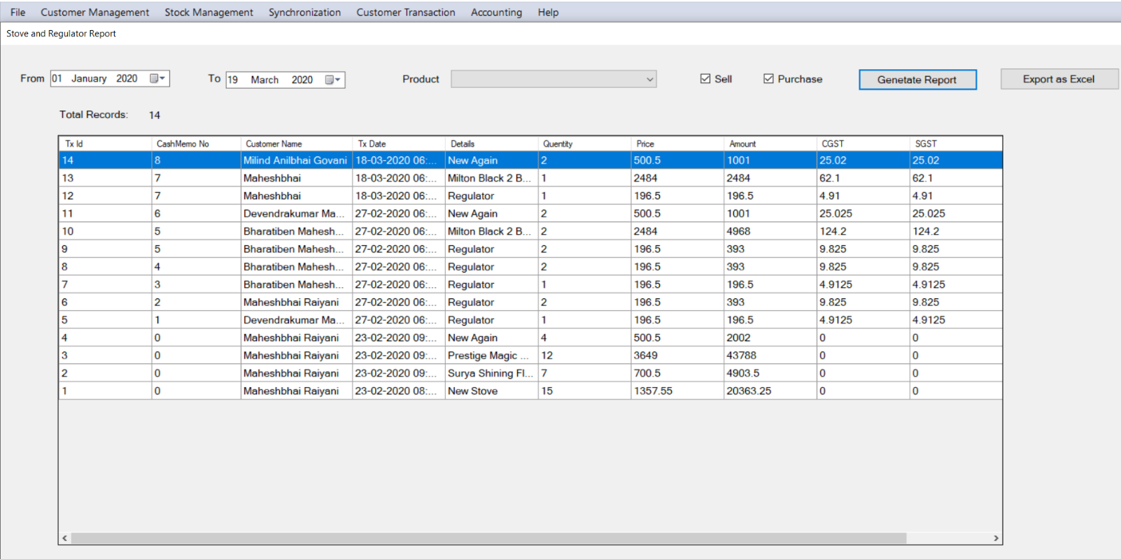

**CONCLUSION**

In this software, there is only one user that is Distributor User. Distributor User can add new customers, change existing customers’ details, close connection, get list of all existing customers as a Customer Management. He/ She can add and view stock and set prices of cylinders, stoves and regulators as a Stock Management. He/ She can book cylinder and generate invoice for existing customers and generate invoice of stove and regulator for any customer as a Customer Transactions. He/ She can get summary report, cylinder report, stove and regulator report for a given specific period. He/ She can synchronize local database with central database to send day to day work to the higher officer.

**LIMITATIONS**

***&***

**FUTURE EXTENSION**

* Limitations:

- Distributor can’t generate bulk invoice

* Not Implemented Functionalities:

- Customers of one agency can be transferred to another agency

* Future Extension:

- Distributor can generate bulk invoice

- Customers of one agency can be transferred to another agency

**BIBLIOGRAPHY**

To develop this project we have taken reference from following websites,

* StackOverflow - <https://stackoverflow.com/>
* Microsoft Documentation - <https://docs.microsoft.com/>
* C# Corner - <https://www.c-sharpcorner.com/>
* YouTube playlist of kudvenkat- <https://www.youtube.com/user/kudvenkat>